SMART ATTENDANCE USING FACIAL RECOGNITION

A project report in partial fulfillment for the award of the degree of

BACHELOR OF TECHNOLOGY
in

COMPUTER SCIENCE AND SYSTEMS ENGINEERING

Submitted by

Abdul Wazeed(314106410001) Gali Saketh(314106410010) Surla Sai Kalyan(314106410028)


DEPARTMENT OF COMPUTER SCIENCE AND SYSTEMS ENGINEERING ANDHRA UNIVERSITY COLLEGE OF ENGINEERING (A)
ANDHRA UNIVERSITY, VISAKHAPATNAM-530003

APRIL 2018

DEPARTMENT OF COMPUTER SCIENCE AND SYSTMS ENGINEERING ANDHRA UNIVERSITY COLEGE OF ENGINEERING (AUTONOMOUS)
ANDHRA UNIVERSITY, VISAKHAPATNAM -530003



CERTIFICATE

This is to certify that the project titled "SMART ATTENDANCE USING FACIAL RECOGNITION" is a certified record of work done by Mr.Abdul Wazeed(Regd No:314106410001), Mr.Gali Saketh(Regd No:314106410010), Mr.Surla Sai Kalyan (Regd No:314106410028) students of B.Tech in the Department of Computer Science & Systems Engineering, Andhra University College of Engineering (A), Andhra University, Visakhapatnam during the period 2014-2018 in the partial fulfillment of the requirements for the award of B.Tech. This work has not been submitted to any other university for the award of Degree or Diploma.


Prof. M. S. Prasad Babu Project Guide Department of CS & SE
Andhra University college of engineering(A)
Prof. P. V. G. D. Prasad Reddy Head of the Department, Department of CS & SE

Andhra University college of engineering (A)

DECLARATION

We hereby declare that the project entitled “SMART ATTENDANCE USING FACIAL RECOGNITION” is an original and authentic work done in the Department of Computer Science & Systems Engineering, Andhra University College of Engineering (A), Andhra University, Andhra University, Visakhapatnam, submitted in partial fulfillment of the requirements for the degree of Bachelor of Technology.

Abdul Wazeed(314106410001)
Gali Saketh (314106410010)
Surla Sai Kalyan(314106410028)

Signature

ACKNOWLEDGEMENT

We have immense pleasure in expressing our earnest gratitude to our Project Supervisor Prof. M. S. Prasad Babu, Vice Principal, Andhra University college of engineering(A) and professor in the Department of Computer Science and Systems Engineering for his inspiring and scholarly guidance. Despite his pre- occupation with several assignments, he has been kind enough to spare his valuable time and gave the necessary counsel and guidance. We received at every stage of planning and constitution of this work.
I express our sincere gratitude to Prof. P. V. G. D. Prasad Reddy, Head of the Department, Department of Computer Science and Systems Engineering, for having accorded us permission to take up this Project work
We are grateful to Prof P.S. Avadhani, Principal, Andhra university College of Engineering (A), Andhra University, Visakhapatnam for providing necessary facilities in the college.
We extend our sincere thanks to our teaching faculty, supporting staff and office-staff for their continuous help throughout our study.

CONTENTS

Chapter
- Introduction

  - Organization of project report

- Problem analysis

  - Motivation

  - Objectives

  - Existing system

  - Proposed system

    - Scope Of the system

    - Automated Attendance System

    - Need of the system

  - System Specifications

    - Software Components

    - Hardware Components

- Requirement Analysis

  - Functional requirements

    - Input Requirements

    - Output requirements

    - Storage requirements

    - Computational requirements

  - Non – Functional requirements

Page
1

6

8
9

9

10

10

10

10

11

12
12

12

13

14

14

14

15

15

16

- Methodology

  - Introduction

  - Design Implementation

    - Image acquisition

    - Face Detection

    - Image Preprocessing

    - Feature Extraction

    - Face Recognition

- Coding

  - Matlab code for Graphical User Interface

    - Code for Graphical User Interface

  - Matlab code for Face Detection

    - for Face Detection

5.3 Matlab code for Face Recognition and Attendance marking
5.3.1 Code for Face Recognition
  - Attendance Report GUI
    - Matlab code for Attendance Report GUI 5.5.Creating Training Data set

- Results and Discussions

  - Attendance Report

  - Database Table

  - Face Recognition

  - Automated Attendance

Page
17

18

21

21

22

26

29

33

36

37

37

40

40

41

41
42

42

47

50

51

52

53

54

- Conclusion and future enhancements 56
  - Conclusion 57
7.2..Future Enhancements 57
REFERENCES BIBLOGRAPHY

LIST OF FIGURES Page No
  - Overview Of The System 19
  - Image Acquisition 21
  - Types Of Haar Features 23
  - Integral Image Representation 24
  - Adaboost Classifier Grouping Process 25
  - Cascading Classifier 26
  - Image Cropping 27
  - Image Resize 28
  - Changing Brightness 29
  - Decision Boundaries for the plugin classifiers 35
  - Attendance Report 51
  - Data stored in Database 52
  - Face Recognition 52
  - Face Recognition of all faces in a group photo 54
  - Automated Attendance System 55
  - Monitoring System 55

ABSTRACT

In the current era, human beings always try to develop a system that minimizes human efforts by implementing automation in the existing system with the help of software and hardware platforms available. Data, process, people, governance and technology are the five main factors in the modern organization. Attendance is the one of the prime factor for controlling and monitoring the projects handled by an organization. In the era of Information Technology, organizations are migrating to automated attendance system for monitoring and surveillance of their people in the organization. This method will also helpful for student attendance in the classroom. Biometric techniques are used for automated attendance and facial recognition is one of the best methods because it needs minimum human interference.
This project mainly focuses on automating the attendance system by face detection and recognition. Facial recognition encompasses training the machine with training dataset containing facial images of all the students. In this project, surveillance footage using CCTV camera is collected and the digital image frames of the students are extracted periodically and an algorithm is applied to it to detect the face of the students and recognize them based on the training data set that was stored in the image database.
The training process involves extracting essential facial features from the training set. We have used Histogram of oriented Gradient method as the feature extraction method. A classification model is built on the extracted feature set using support vector machine combined with error correcting output codes (ECOC). During runtime, this trained classification model is used to recognize the students present in the class and mark their attendance in a data base table. This process continues until all the detected faces of students get their attendance marked in database. Now this database is used to process the student’s individual attendance and percentage. We can also view the compete record of attendance.

CHAPTER - 1

INTRODUCTION

Usually in the organizations, people used to record the attendance on sheets. This system is time taking and effort consuming. The rapid developments in the field of pattern recognition, especially the applications of signature recognition, facial recognition, may be used in the large organizations for recognition of objects and people. Biometric recognition is one of the identification systems that recognize an individual based on human features like finger print, face, iris, etc. Most of the biometric recognition techniques are not fully automated. At present organizations normally use Finger print recognition system which involves placing the finger print on the scanner. But the fingerprint system has some limitation such as: If there are dust particles either on the surface of the finger or scanner, the system may not be able to recognize the finger print efficiently and causes inconvenience to the organizations.

Face recognition is an automated biometric recognition technique that uses minimum human interference. This system is efficient in working when compared to other methods as the system removes the burden of active participation of individual during attendance process. The system authenticates individuals, by taking their images, process them and then put the attendance basing on the information present in its database. It is in this context the authors considered to develop an automated attendance system based on facial recognition for their project work. The project report is organized into seven chapters.

Organization of the Project Report

Chapter 1: INTRODUCTION
This chapter discusses brief description of attendance and its automation. Attendance and attendance automation is examined and scope of the project is defined.

Chapter 2: PROBLEM ANALYSIS
This chapter deals with the motivation behind the problem and the problem statement. The current scenario is described in the existing system. A proposed system is discussed which is the main idea of the project. Objectives of the project are thoroughly analyzed.

Chapter 3: REQUIREMENT ANALYSIS
This chapter gives a detailed description of all the requirements either software or hardware. It presents an evaluation of the input and output requirements, computer and storage requirements.

Chapter 4: METHODOLOGY
In this chapter the proposed system has been discussed. The algorithm that has been used is discussed in detail which contains 2 phases one for the detection of the face and other for its recognition. Automation is also done in order to get the training data in to the required format.

Chapter 5: CODING
This chapter contains the code of various modules from retrieving camera data and processing it and then displays the result using the graphical user interface.

Chapter 6: RESULTS AND DISCUSSIONS
This chapter evaluates the results obtained from the algorithms run on the camera data and data storage and the outputs are discussed at each stage.

Chapter 7: CONCLUSION AND FUTURE ENHANCEMENTS
This chapter describes the final conclusions and evaluates if the project meets the desired objective successfully. The chapter also explores the future enhancements that can be accomplished in order to modify the project.

CHAPTER – 2

PROBLEM ANALYSIS

In this chapter, the problem statement is discussed. The motivation of the project in section 2.1, the objectives of the project in section 2.2, the existing system in section 2.3, the proposed system with system specification, software and hardware components in section 2.4 are discussed in the chapter.

Motivation
The increase in amount of data available along with better computation power to process the data has led to development of various algorithms which can be used to gain insights from the data and make predictions. Data mining may be defined as a process of extracting useful knowledge in the form of relations and patterns from large amount of data. Machine Learning is an application of Data mining, which allows software application to become more accurate in predicting outcomes without being explicitly programmed. The basic premise of machine learning is to build algorithms that can receive input data and use statistical analysis to predict an output value within an acceptable range. In this project, we have used machine leaning techniques to build the automated attendance system which learns on its own and mark the attendance.

Objectives

Specific objectives to this project are:
    - Overcome the old attendance system in which the attendance has to be taken manually.
    - Attendance is marked without student participation and minimal human effort is required to maintain the system.
    - The storage of data helps to keep track of each students attendance
Record and to calculate attendance percentage academic purpose.
    - A report is generated on demand for verification to the user.

Existing System
The existing system is mostly monitored manually. In this system each student should individually respond to the attendance call made by the lecturer and the attendance is marked basing on that. This usually consumes a lot time and there may be a chance of duplicate entries. The following are the drawbacks of the existing system:
    - Duplication of data entry.
    - Time consuming to mark each person attendance.
    - Distracts students and lecturers attention.
    - If the attendance sheet is lost, the data is also lost
    - Retrieval of the information is not as easy as the records are maintained in the registers.

Proposed System

Scope of the System
Designed to mark the attendance automatically without the participation of the student and the administrator. The student registration should be done prior to the recognition. The attendance is marked in the database which can be used to calculate the attendance percentage and also to generate the report.

Automated Attendance System

Smart Attendance system is attendance software which has a complete time and attendance management solution that automates all your attendance processes.

Need of the System
It is almost impossible for humans to compute the functions that were imposed on the images which are obtained as input data to generate some results basing on which the attendance is marked. So the work is given to machine to do all the computations and mark the attendance for the student and even compute their attendance percentage.

The proposed system has two phases namely student registration and student recognition. Each has 4 components in common namely:

- Image acquisition
- face detection
- data preprocessing
- feature extraction

The second phase has one more component named recognition. The input to the system is surveillance video from which a frame is taken and is passed through all the mentioned components and using the matched label we mark the attendance in the database for the particular student. A report is generated if the user wants to verify the attendance. The main advantage of the system is the student need not participate for their attendance to be marked and also overcomes the above drawbacks.

System Specification
The specifications of the system, used in the processing,
are as follows:
- Operating system : Windows 10
- RAM : 4GB
- Hard Disk : 1TB

Software Components
- MATLAB
- MySQL

Hardware Components
- Camera with High Resolution
- PC with High Computational Power

CHAPTER – 3

REQUIREMENT ANALYSIS

In this chapter the input requirements in section 3.1, output requirements in section 3.2, computer requirements in section 3.3, storage requirements in section 3.4 are discussed.
  - Functional requirements
The functional requirements of the computer system used are:
- Adding a new student to the training database
- The system recognize the student int the class room and marks the attendance
- The student must be able to view their attendance report.

Input Requirements
For effective performance of the system various parameters must be taken in to consideration. The parameters are given below:

    - Well illuminated classrooms
    - High resolution camera
    - PC with high computation power
    - Training dataset containing 10 images for each individual of respective class

Output Requirements
System is designed in such a way to store the attendance report in database. The output of the system is attendance report The output requirements are:
- The output must be stored in database and can be previewed whenever it is required for verification.
- The attendance percentage is calculated from the attendance report.
- The output report should be generated in a excel sheet on demand.

Storage Requirements
The data is stored in the database using Structured Query Language (SQL). Data is the cropped facial images of each individual.
- .Each image file is of size 10kiloBytes
- The training set contains set of 10 images for each student present in the class.
- The training dataset will be a size of 5Megabytes.
- The source code is of size 300 kilobytes.
- Each video footage size may be in range of 10 megabytes to
several hundreds of Megabytes .
The output attendance data is stored in database and also in excel file sheet. The saved data can be periodically analyzed to calculate attendance percentage and also to present complete attendance report. The software necessary for storage is:
    - MySQL Database

    - Computational Requirements
The computations are done by the pre-defined functions present in the mat lab which are listed as below:
- For feature extract we used the below function:
extractHOGFeatures(queryImage);

The features are returned in a 1-by-N vector, where N is the HOG feature length. The returned features encode local shape information from regions within an image.
- For predicting the class we use the below function:

Predict(Mdl,X);

This returns a vector of predicted class labels for the predictor data in the table or matrix X, based on the trained, full or compact classification tree Mdl.

Nonfunctional Requirements
The non-functional requirements of the computer system used in the study are:
- Operability: The system is designed using MATLAB
- Security: the system shall provide access to only registered users.
- Performance: The system will process attendance information within 10 seconds of submission

CHAPTER – 4

METHODOLOGY

In this chapter, the design of the proposed system is discussed. The system overview has been discussed in the section 4.1, by explaining the components involved in the attendance automation. The working of the design is explained in section 4.2, which contains 5 sections namely Image Acquisition unit in section 4.2.1, Face Detection in section 4.2.2, Image preprocessing in section 4.2.3, Feature extraction and selection in section 4.2.4, Face Recognition in section 4.2.5.

The proposed system takes a frame as input and processes it in each component as listed above. Now the end result obtained is used to mark the attendance and calculate the percentage.

4.1. System Overview
The system has two phases they are enrollment of the student in system, recognition of the student and put their attendance.

- Camera captures the video of the classroom and then sent to the system.
- Now the frames are extracted from the video and are used for further processing.
- The faces are detected and are cropped from the frame and stored in the database.
- Now the cropped images are preprocessed in-order to obtain better results during feature extraction phase.
- The algorithm is run to extract features which are used for the recognition of the face.
- The above results are compared with the trained data to predict the outcome.
- The outcomes are then placed in database.

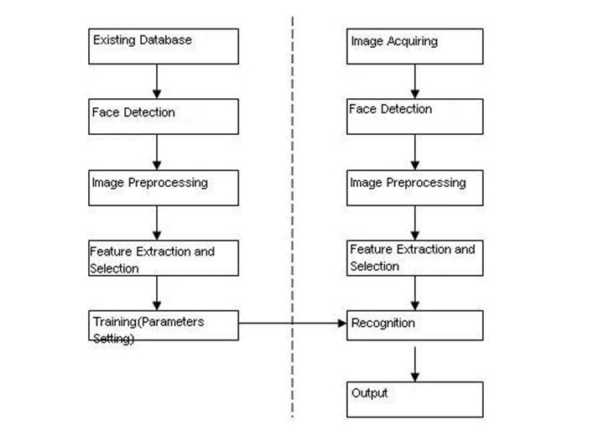

Fig 4.1: Overview of the system

- Student Enrollment process involves registration of the student with the system. For registration process student need to come in front of the camera. At the time of the registration, student’s faces with different orientations are saved inside the database. In order to detect the student
faces we use VIOLA-JONES face detection algorithm which is discussed in section 4.2.2.
  - The existing database consists of the images that were taken by the camera at the time of registration.
  - The faces are detected using VIOLA-JONES algorithm which is then sent for data preprocessing.
  - In data preprocessing the image intensity is increased and resized.
  - Histogram of Oriented Gradients is used to extract the features.

- Student Recognition is the process of identifying student faces present in the database. To recognize the human face we extract the features from the faces that are available in the frames and compare these features with the features of the faces present in the database (Training set). In order to recognize the student’s faces we use ERROR CORRECTING OUTPUT CODE (ECOC) classification algorithm with PREDICT function which is discussed in section 4.2.5.
  - The image acquisition is done using some input device.
  - Now the image is used to detect the faces present in it and they are cropped.
  - Image processing is done.
  - Using Histogram of Oriented Gradients (HOG) is used to extract the features.
  - Now the face recognition is done using the ERROR CORRECTING OUTPUT CODE (ECOC) classification algorithm.
  - Using the predict function we compare the above result with the trained data present in the database.
  - The best match label is used to mark the attendance

4.2. DESIGN IMPLEMENTATION
Each phase consists of four components namely Image Acquisition, Face Detection, Image Preprocessing, feature extraction. The student recognition phase has an extra component namely Face Recognition. The proposed system is implemented using MATLAB and Structured Query Language(SQL).

Image Acquisition
Digital imaging or digital image acquisition is the creation of photographic images, such as of a physical scene or of the interior structure of an object.
There are two ways to use the video surveillance data, we either use live video from surveillance camera for recognition or we may use offline video which is already recorded and available somewhere in the system.
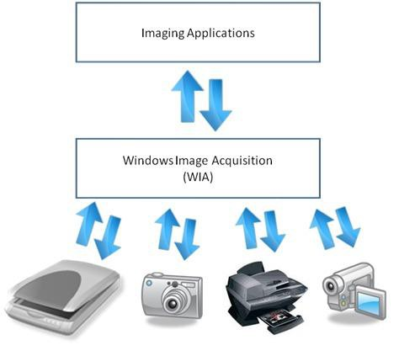
Fig 4.2: Image acquisition

Image Acquisition Toolbox provides functions and blocks that enable you to connect industrial and scientific cameras to MATLAB and Simulink. It includes a MATLAB app that lets you interactively detect and configure hardware properties. The toolbox enables acquisition modes such as processing in-the-loop, hardware triggering, background acquisition, and synchronizing acquisition across multiple devices.
Image Acquisition Toolbox supports all major standards and hardware vendors, including USB3 Vision, GigE Vision, and GenICam GenTL. You can connect to 3D depth cameras, machine vision cameras, and frame grabbers, as well as high-end scientific and industrial devices.

Face Detection
We used viola Jones face detection algorithm for human face detection. Viola Jones algorithm have several advantages over other face detection algorithm. We choose viola jones algorithm because it uses an integral image representation as well as AdaBoost due to this it will give better performance in different lighting conditions. The details of viola jones algorithm are as follows: Four steps carried out during implementation of Viola-Jones face detection algorithm are as follows:

Selection of Haar features
Haar features are digital image features used in face detection process. These features are moved over an image to detect an object. These features have two regions one is white and second is black. The computation carried out during haar feature selection is as follows eqn.

Val=Σ(pixels in black region) -Σ(pixels in white region)(1)
In order to detect human faces the below features are applied on human faces and then threshold value is calculated by using above mentioned formula.

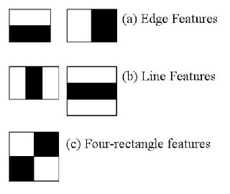

Fig 4.3: Types of Haar Feature

Several types of haar features applied on an image is shown in the Fig.2.These features are developed by considering human face characteristics so that it will help us to detect the human face with great accuracy . The features are selected based some of the properties associated with human faces. Such as region of the eyes has been often darker than region of the nose and cheeks. The second property is that eyes are darker than the bridge of the nose. But the same windows applying on the cheeks or any other place are irrelevant. So, among the 160000 features available appropriate features are selected using AdaBoost. In AdaBoost each feature is applied on all the training images. After that it finds the threshold value for each feature based on that faces are classified either as positive or negative. At the time of feature selection there will be errors or misclassification but we select the features with the minimum error rate.

Integral image representation
If the image is of dimension 24*24 then that have near about 160000 features available to identify a human face. If we perform computation using all these features on the image then it will take too much time for computation. So to have a high-speed image is represented as an integral image. The integral image at location (x, y), is the sum of the pixels above and to the left of (x, y), inclusive.
ii(x, y)= Σ i (x’, y’) (2) x’≤ x, y’≤ y
Eqn.2 combines neighbour pixel values for easy of calculation. Here ii(x,
y) is integral image and i(x, y) is the original image. Fig.3: Integral image representation.

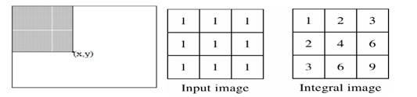
Fig 4.4: Integral Image Representation

AdaBoost Training
Though we have 160000 haar features but out of that only some features are capable to work independently .To overcome above limitation weak classifiers is grouped together. The process of grouping weak classifiers is called AdaBoost. The set of weak classifiers represented using below equation.

hj(x) ∈{+1, -1} (3)
If we iteratively combine these classifiers the equation in the linear form is

C(z)= θ( Σ ht (x)+b ) (4)
Eqn. 3 is use to declare classifier either as a weak or strong based on the value obtained from Eqn.1. Eqn. 4 combines the features having value greater than threshold value.It helps in the process of detection and recognition process.
The whole process carried out during AdaBoost training is shown in Fig. 4

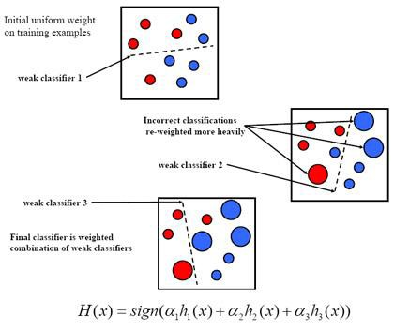

Fig 4.5: AdaBoost Classifier grouping process

Cascading classifier
As image having dimension 24*24 has near about 160000 features, If we use all these features to detect an object as a face in the image, then computational time will be more.so the alternative is to use cascading classifier in which at each stage classifiers are grouped together

to detect the face. Image face property not found then we simply discard that classifier and proceed to next classifier. Due to this computational time is reduced. The overview of the cascading classifier is shown in fig.5
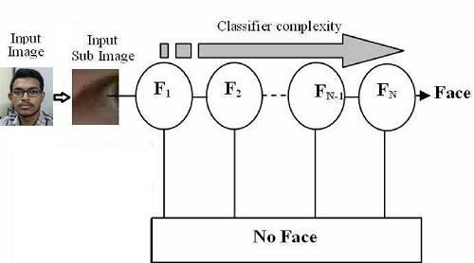

Fig 4.6: Cascading classifier
4.2.3. Image Preprocessing
Image preprocessing can extensively increase the trustworthiness of an optical inspection. Numerous filter techniques that further intensify or reduce a particular image information allow easier or much faster evaluation. Users can optimize a camera image with just a few clicks. Image preprocessing decrease processing time and increase the chances of accurate matching [5]. Face images are preprocessed to satisfy the requirements of feature extraction.

Image Cropping
The selection of specific set of preprocessing steps differs according to the particular application concerned. All the face images used from the database are manually aligned by adjusting the location of the eyes. Therefore, all the faces are rotated initially to set the centers of the eyes on particular pixels. The image region where the face can be found is then cropped and only this region is used in the face recognition process. The
face is cropped from the whole image manually depending on the position of the left and right eyes as well as the mouth. Lastly, all the new images need similar dimensions. Therefore, after cropping the face from the original image, the new images are normalized to a standard size of 64 x 64 pixels as shown in Fig 2.
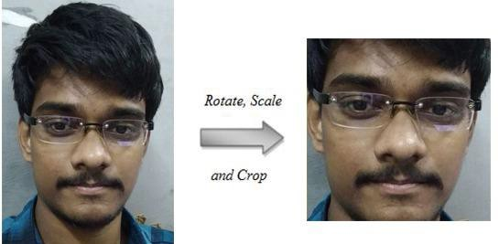

Fig 4.7: Image Cropping

Image Resize
The images used in the analysis are resized in different scales to determine how various sizes affect the recognition process. Different image sizes carry different information that’s why the best image size needs to be examined in details. The purpose of image resizing is to produce a lower data size, which hastens the processing time. The resize scale randomly varies from 0.1 to 0.9 values, which produces different image sizes. Fig 3 shows an example of image resizing with a scale of 0.5. Resizing the image to a small scale can lead to the loss of many important features, especially if the image texture is used during classification. Fig 4 shows an example of the feature lost when the image is seized with a scale of 0.25.

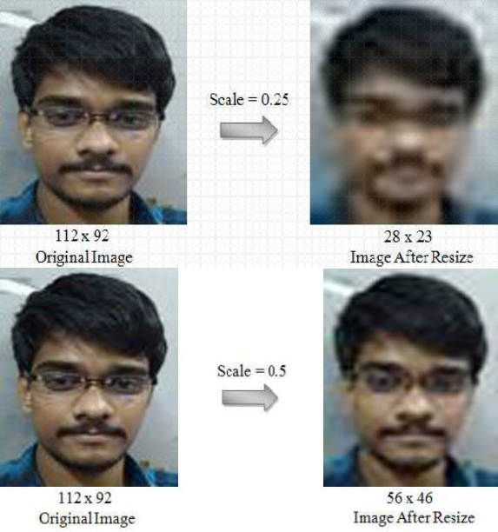

Fig 4.8: Image Resize

Changing the Brightness
Changing the brightness is one of the easiest pre-processing techniques. Brightness refers to the overall lightness or darkness of the image. To increase brightness, some constant values must be added to each pixel. To decrease the brightness, some constant values must be deducted from each pixel. The value of brightness usually from -255 to +255. Negative values will darker the image and positive values will brighten the image. Fig 5 shows an example of increasing image brightness. Darker or lighter images can be needed in some cases.

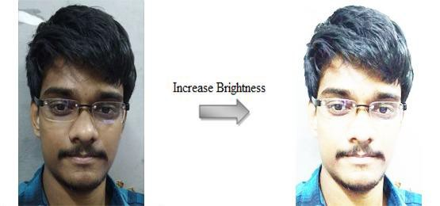

Fig 4.9: Changing The Brightness

Feature Extraction
In this phase, the preprocessed image is given to the Histogram of Oriented Gradients (HOG) which extracts the features from the image.

HISTOGRAM OF ORIENTED GRADIENTS (HOG)
It is a feature descriptor used in computer vision and image processing for the purpose of object detection. The technique counts the occurrences of gradient orientation in localized portion of an image. This method is similar to that of edge orientation histograms, scale invariant feature transform descriptors, and shape context, but differs in that it is computed on a dense grid of uniformly spaced cells and uses overlapping local contrast normalization for improved accuracy.

There are 5 steps in algorithm implementation they are:
      - Gradient computation
      - Orientation Binning
      - Descriptor Blocks
      - Block Normalization
      - Object Recognition

Gradient computation

The first step of calculation in many feature detectors in image pre- processing is to ensure normalized color and gamma values. As Dalal and Triggs point out, however, this step can be omitted in HOG descriptor computation, as the ensuing descriptor normalization essentially achieves the same result. Image pre-processing thus provides little impact on performance. Instead, the first step of calculation is the computation of the gradient values. The most common method is to apply the 1-D centered, point discrete derivative mask in one or both of the horizontal and vertical directions. Specifically, this method requires filtering the color or intensity data of the image with the following filter kernels:

[-1,0,1] and [-1,0,1]T

Dalal and Triggs tested other, more complex masks, such as the 3x3 Sobel mask or diagonal masks, but these masks generally performed more poorly in detecting humans in images. They also experimented with Gaussian smoothing before applying the derivative mask, but similarly found that omission of any smoothing performed better in practice.

Orientation binning

The second step of calculation is creating the cell histograms. Each pixel within the cell casts a weighted vote for an orientation-based histogram channel based on the values found in the gradient computation. The cells themselves can either be rectangular or radial in shape, and the histogram channels are evenly spread over 0 to 180 degrees or 0 to 360 degrees, depending on whether the gradient is “unsigned” or “signed”. Dalal and Triggs found that unsigned gradients used in conjunction with 9 histogram channels performed best in their human detection experiments. As for the vote weight, pixel contribution can either be the gradient magnitude itself, or some function of the magnitude. In tests, the gradient magnitude itself generally produces the best results. Other options for the vote weight could include the square root or square of the gradient magnitude, or some clipped version of the magnitude.

Descriptor blocks

To account for changes in illumination and contrast, the gradient strengths must be locally normalized, which requires grouping the cells together into larger, spatially connected blocks. The HOG descriptor is then the concatenated vector of the components of the normalized cell histograms from all of the block regions. These blocks typically overlap, meaning that each cell contributes more than once to the final descriptor. Two main block geometries exist: rectangular R-HOG blocks and circular C-HOG blocks. R-HOG blocks are generally square grids, represented by three parameters: the number of cells per block, the number of pixels per cell, and the number of channels per cell histogram. In the Dalal and Triggs human detection experiment, the optimal parameters were found to be four 8x8 pixels cells per block (16x16 pixels per block) with 9 histogram channels. Moreover, they found that some minor improvement in performance could be gained by applying a Gaussian spatial window within each block before tabulating histogram votes in order to weight pixels around the edge of the blocks less. The R-HOG blocks appear quite similar to the scale-invariant feature transform (SIFT) descriptors; however, despite their similar formation, R- HOG blocks are computed in dense grids at some single scale without orientation alignment, whereas SIFT descriptors are usually computed at sparse, scale-invariant key image points and are rotated to align orientation. In addition, the R-HOG blocks are used in conjunction to encode spatial form information, while SIFT descriptors are used singly.

Block normalization

Dalal and Triggs explored four different methods for block normalization. Let be the non-normalized vector containing all histograms in a given block, be its k-norm for and be some small constant (the exact value, hopefully, is unimportant). Then the normalization factor can be one

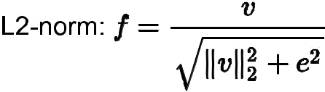

L2-hys: L2-norm followed by clipping (limiting the maximum values of v to 0.2) and renormalizing, as in[7]

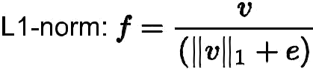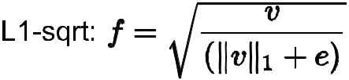

In addition, the scheme L2-hys can be computed by first taking the L2- norm, clipping the result, and then renormalizing. In their experiments, Dalal and Triggs found the L2-hys, L2-norm, and L1-sqrt schemes provide similar performance, while the L1-norm provides slightly less reliable
performance; however, all four methods showed very significant improvement over the non-normalized data.

Object recognition

HOG descriptors may be used for object recognition by providing them as features to a machine learning algorithm. Dalal and Triggs used HOG descriptors as features in a support vector machine (SVM) however, HOG descriptors are not tied to a specific machine learning algorithm.

Face Recognition
The recognition of the face using the extracted features is done by the ERROR CORRECTING OUTPUT CODE algorithm with the prediction function. Error-correcting output coding is a recipe for solving multi-way classification problems. It works in two stages: First, independently construct many subordinate classifiers, each responsible for removing some uncertainty about the correct class of the input; second, apply aVoting scheme to decide upon the correct class, given the output of each weak learner.
The idea of classifying by consensus" using a large number of independently-constructed classifiers have appeared in a number of other guises recently in the machine learning literature. The technique of bagging, for instance, involves generating multiple training sets by
Sampling with replacement, learning a classifier from each generated set, and allowing the learned classifiers to vote on the correct class for a unlabeled object. Boosting can be viewed as a special case of bagging where the sampling is adaptive, concentrating on misclassified training instances.
We describe the technique of error-correcting output coding with a simple example: the task of classifying newswire articles into the m = 4 categories [Politics, sports, business, and arts]. To begin, one assigns a unique n-bit vector to each label (where n > log2m):

POLITICS – 0110110001
SPORTS – 0001111100
BUSINESS – 1010101010
ARTS – 1000011010

One can view the ith bit vector as a unique coding for label i. For this reason (and others, which will soon become apparent), we'll refer to the set of bit vectors as a code and denote it by C. The ith row of C we will write as Ci, and the value of the jth bit in this row as Cij .The second step in constructing an ECOC classifier is to build an individual binary classifier for each column of the code-10 classifiers in all, in this case. The positive instances for classifier j are documents with a label for which Cij = 1. The third classifier, for instance, has the responsibility of distinguishing between documents whose label is sports or arts and those whose label is politics or business. Heeding to convention, we refer generically to any algorithm for predicting the value of a single bit as a “plug-in classifier" (PiC). A PiC, then, is a predictor of whether a document belongs to some fixed subset of the classes. With /\ in hand, one can hypothesize the correct class of an unlabeled document x as follows. Evaluate each independent classifier on x, generating a n-bit vector /\(x) = {Lambda^1(x), Lambda^2(x),.., Lambda^n(x)}. Most likely, the generated bit vector /\(x) will not be a row of C, but it will certainly be closer to some rows than to others. Categorizing the document x involves selecting argmini Triangle(Ci, /\(x)), the label i for which Ci is closest to /\(x).

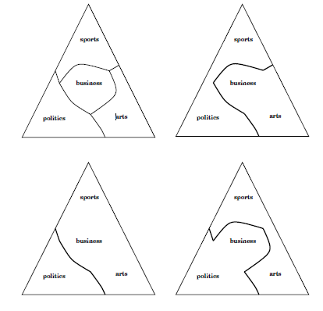
Fig 4.10: Decision boundaries for the first three plug-in classifiers

To the extent that rows of C are well-spaced in Hamming distance, the classifier will be robust to a few errant PiCs. This is the idea behind error- correcting codes as well: to transmit a point in the m-dimensional cube reliably over a noisy channel, map it to one of a set of well separated “fixed points" in a higher-dimensional cube; to recover the original point, find the closest fixed point to the point actually received and take its pre-image in the original cube.

CHAPTER –5

CODING

MATLAB Code for Graphical User Interface

    - Code for Graphical User Interface

function varargout = basic(varargin) gui_Singleton = 1;
gui_State = struct('gui_Name', mfilename, ... 'gui_Singleton', gui_Singleton, ... 'gui_OpeningFcn', @basic_OpeningFcn, ... 'gui_OutputFcn', @basic_OutputFcn, ... 'gui_LayoutFcn', [] , ...
'gui_Callback', []); if nargin && ischar(varargin{1})
gui_State.gui_Callback = str2func(varargin{1}); end

if nargout
[varargout{1:nargout}] = gui_mainfcn(gui_State, varargin{:}); else
gui_mainfcn(gui_State, varargin{:}); end
% End initialization code - DO NOT EDIT

% --- Executes just before basic is made visible.
function basic_OpeningFcn(hObject, eventdata, handles, varargin)

conn = database('students_details','root','root'); setappdata(0,'con',conn);

% This function has no output args, see OutputFcn.
% hObject handle to figure
% eventdata reserved - to be defined in a future version of MATLAB
% handles structure with handles and user data (see GUIDATA)
% varargin command line arguments to basic (see VARARGIN)

% Choose default command line output for basic handles.output = hObject;

% Update handles structure guidata(hObject, handles);

% UIWAIT makes basic wait for user response (see UIRESUME)
% uiwait(handles.figure1);

% --- Outputs from this function are returned to the command line. function varargout = basic_OutputFcn(hObject, eventdata, handles)
% varargout cell array for returning output args (see VARARGOUT);
% hObject handle to figure
% eventdata reserved - to be defined in a future version of MATLAB
% handles structure with handles and user data (see GUIDATA)

% Get default command line output from handles structure
varargout{1} = handles.output;

function edit1_Callback(hObject, eventdata, handles)
% hObject handle to edit1 (see GCBO)
% eventdata reserved - to be defined in a future version of MATLAB
% handles structure with handles and user data (see GUIDATA)

% Hints: get(hObject,'String') returns contents of edit1 as text
% str2double(get(hObject,'String')) returns contents of edit1 as a double

% --- Executes during object creation, after setting all properties. function edit1_CreateFcn(hObject, eventdata, handles)
% hObject handle to edit1 (see GCBO)
% eventdata reserved - to be defined in a future version of MATLAB
% handles empty - handles not created until after all CreateFcns called

% Hint: edit controls usually have a white background on Windows.
% See ISPC and COMPUTER.
if ispc && isequal(get(hObject,'BackgroundColor'), get(0,'defaultUicontrolBackgroundColor')) set(hObject,'BackgroundColor','white');
end

% --- Executes on button press in togglebutton1.
function togglebutton1_Callback(hObject, eventdata, handles)
% hObject handle to togglebutton1 (see GCBO)
% eventdata reserved - to be defined in a future version of MATLAB
% handles structure with handles and user data (see GUIDATA)

% Hint: get(hObject,'Value') returns toggle state of togglebutton1

% --- Executes on button press in Attendance.
function Attendance_Callback(hObject, eventdata, handles) c=getappdata(0,'con');
basic2(c);
% hObject handle to Attendance (see GCBO)
% eventdata reserved - to be defined in a future version of MATLAB
% handles structure with handles and user data (see GUIDATA)

%{
% --- Executes on button press in Emotions.
function Emotions_Callback(hObject, eventdata, handles) d = getappdata(0,'con');
curs = exec(d,'SELECT * FROM student_report'); curs = fetch(curs);
an=curs.Data; Emo(an);
%}
% hObject handle to Emotions (see GCBO)
% eventdata reserved - to be defined in a future version of MATLAB
% handles structure with handles and user data (see GUIDATA)
%main();

% --- Executes on button press in Exit.
function Exit_Callback(hObject, eventdata, handles)
close basic; close;
% hObject handle to Exit (see GCBO)
% eventdata reserved - to be defined in a future version of MATLAB
% handles structure with handles and user data (see GUIDATA)

% --- If Enable == 'on', executes on mouse press in 5 pixel border.
% --- Otherwise, executes on mouse press in 5 pixel border or over Attendance. function Attendance_ButtonDownFcn(hObject, eventdata, handles)
% hObject handle to Attendance (see GCBO)
% eventdata reserved - to be defined in a future version of MATLAB
% handles structure with handles and user data (see GUIDATA)
% --- Executes on button press in start_monitoring.
function start_monitoring_Callback(hObject, eventdata, handles)
%%------------------TIME FILE FOR COLUMN NAMES IN DAtABASE--------------------%%
rmdir('C:\Users\Wazeed\Desktop\fix\PROJECT\test','s') mkdir('C:\Users\Wazeed\Desktop\fix\PROJECT\test') try
load timedb.mat; time = timedb; disp(time);
catch
time = 1;
save timedb.mat time; end
if (strcmp(handles.start_monitoring.String,'Start Monitoring') == 1) handles.start_monitoring.String = 'Stop Monitoring'; msgbox('Monitoring....');
conn = database('students_details','root','root');
%%---------------looping------------
for loop = time:time%+2 time = loop +1;
save timedb.mat time; DETECTFACE(conn,loop); pause(10);
if (strcmp(handles.start_monitoring.String,'Start Monitoring') == 1) handles.start_monitoring.String = 'Start Monitoring';
break;

end end
handles.start_monitoring.String = 'Start Monitoring';

else
handles.start_monitoring.String = 'Start Monitoring';

end
% hObject handle to start_monitoring (see GCBO)
% eventdata reserved - to be defined in a future version of MATLAB
% handles structure with handles and user data (see GUIDATA)

%{
% --- Executes on button press in training.
function training_Callback(hObject, eventdata, handles)
% hObject handle to training (see GCBO)
% eventdata reserved - to be defined in a future version of MATLAB
% handles structure with handles and user data (see GUIDATA) module_1_training();
%}

MATLAB Code for Face Detection

5.2.1 Code for Face Detection

function [] = DETECTFACE(conn,cn)
%conn = database ('name of the database' , 'root ', 'pwd');

FDetect = vision.CascadeObjectDetector; FDetect.MergeThreshold = 5;
%cam = VideoReader('C:\Users\Wazeed\Desktop\fix\PROJECT\preprocesstestsamples\testsamples\WhatsApp Video 2018-04-23 at 12.42.27 PM.mp4');
%n = cam.NumberOfFrames;
%n=numFrames;
%for i = 140:141
%I = read(cam,i);
%imshow(I); I=imread('C:\Users\Wazeed\Desktop\fix\PROJECT\preprocesstestsamples\testsamples\1.jpeg');

figure; montage(I); title('Test case');
%imwrite(framed,['Image' int2str(i), '.jpg']);
%im(i)=image(framed);
conn = database('students_details','root','root');
query = sprintf('ALTER TABLE students ADD C%d int(2) NOT NULL',cn) ; curs = exec(conn,query);
curs = fetch(curs); curs.Data; imshow(I);
%cam = webcam('HP Truevision HD');
%I =(snapshot(cam));
%%store snapshot for validation if required!
%I = imread('C:\Users\Wazeed\Desktop\WhatsApp Image 2018-04-23 at 11.02.09 AM.jpeg');
%I=In+100;
% I=imresize(I,0.3); BB = step(FDetect,I);

%BB = step(FDetect,I);
%figure,
%imshow(I);
%hold on
for faces = 1:size(BB,1)
%rectangle('Position',BB(faces,:),'LineWidth',3,'LineStyle','-','EdgeColor','b'); J= imcrop(I,BB(faces,:));
% J=rgb2gray(K);
%J=imresize(J,0.5);
%figure(3);
%subplot(3,3,faces);
% imshow(J); J = J+ 50;
J=rgb2gray(J); J=imresize(J,[112,92]);
path = sprintf('%d.pgm',faces);
% disp(path); imwrite(J,path);

renamed = strcat('C:\Users\Wazeed\Desktop\fix\PROJECT\test\',path) ;
movefile(path, renamed);
%Untitled(conn,cn);
%SimpleFaceRecognition(conn,cn);
%pause(5);
%imshow(J);
%save J6.pgm J;
%RECOGNIZE(J,K,conn,i);
end SimpleFaceRecognition(conn,cn); cn =cn+1;

%}
end

MATLAB Code for Face Recognition and attendance marking

5.3.1 Code for Face Recognition and attendance marking

function [] = SimpleFaceRecognition(conn,cn)
%% Load Image Information from ATT Face Database Directory faceDatabase = imageSet('dataset','recursive');
test = imageSet('test'); training = faceDatabase;
%% Extract HOG Features for training set
trainingFeatures = zeros(size(training,2)*training(1).Count,4680); featureCount = 1;
for i=1:size(training,2)
for j = 1:training(i).Count
trainingFeatures(featureCount,:) = extractHOGFeatures(read(training(i),j)); trainingLabel{featureCount} = training(i).Description;
featureCount = featureCount + 1; end
personIndex{i} = training(i).Description; end

%% Create 40 class classifier using fitcecoc
faceClassifier = fitcensemble(trainingFeatures,trainingLabel);

%% Test First n People from Test Set figure;
figureNum = 1; for person=1:6
for j = 1:test.Count queryImage = read(test,j);
queryFeatures = extractHOGFeatures(queryImage); personLabel = predict(faceClassifier,queryFeatures);
% Map back to training set to find identity booleanIndex = strcmp(personLabel, personIndex); integerIndex = find(booleanIndex);
subplot(1,2,figureNum);imshow(queryImage);title('Query Face');
subplot(1,2,figureNum+1);imshow(read(training(integerIndex),1));title('Matched Class');
% figureNum = figureNum+2;
query = sprintf('UPDATE students SET c%d = 1 WHERE `Number` = %d',cn,integerIndex) ; curs = exec(conn,query);
curs = fetch(curs); curs.Data; pause(2);
end
%figure;
%figureNum = 1;

%clear all; end

MATLAB Code for Attendance report GUI

5.4.1 Code for Attendance report GUI

function varargout = basic2(varargin)
% Begin initialization code - DO NOT EDIT gui_Singleton = 1;
gui_State = struct('gui_Name', mfilename, ... 'gui_Singleton', gui_Singleton, ... 'gui_OpeningFcn', @basic2_OpeningFcn, ... 'gui_OutputFcn', @basic2_OutputFcn, ... 'gui_LayoutFcn', [] , ...
'gui_Callback', []); if nargin && ischar(varargin{1})
gui_State.gui_Callback = str2func(varargin{1}); end

if nargout
[varargout{1:nargout}] = gui_mainfcn(gui_State, varargin{:}); else
gui_mainfcn(gui_State, varargin{:}); end
% End initialization code - DO NOT EDIT

% --- Executes just before basic2 is made visible.
function basic2_OpeningFcn(hObject, eventdata, handles, varargin)

% This function has no output args, see OutputFcn.
% hObject handle to figure
% eventdata reserved - to be defined in a future version of MATLAB
% handles structure with handles and user data (see GUIDATA)
% varargin command line arguments to basic2 (see VARARGIN) c = varargin{1};
setappdata(0,'conn',c);
% Choose default command line output for basic2 handles.output = hObject;

% Update handles structure guidata(hObject, handles);

% UIWAIT makes basic2 wait for user response (see UIRESUME)
% uiwait(handles.figure1);

% --- Outputs from this function are returned to the command line. function varargout = basic2_OutputFcn(hObject, eventdata, handles)
% varargout cell array for returning output args (see VARARGOUT);
% hObject handle to figure
% eventdata reserved - to be defined in a future version of MATLAB
% handles structure with handles and user data (see GUIDATA)

% Get default command line output from handles structure
varargout{1} = handles.output;

function Image_Callback(hObject, eventdata, handles)
% hObject handle to Image (see GCBO)
% eventdata reserved - to be defined in a future version of MATLAB
% handles structure with handles and user data (see GUIDATA)

% Hints: get(hObject,'String') returns contents of Image as text
% str2double(get(hObject,'String')) returns contents of Image as a double

% --- Executes during object creation, after setting all properties. function Image_CreateFcn(hObject, eventdata, handles)
% hObject handle to Image (see GCBO)
% eventdata reserved - to be defined in a future version of MATLAB
% handles empty - handles not created until after all CreateFcns called

% Hint: edit controls usually have a white background on Windows.
% See ISPC and COMPUTER.
if ispc && isequal(get(hObject,'BackgroundColor'), get(0,'defaultUicontrolBackgroundColor')) set(hObject,'BackgroundColor','white');
end

function roll_no_Callback(hObject, eventdata, handles) x=(get(handles.roll_no,'String'));
x=str2num(x); setappdata(0,'reg_no',x);
% hObject handle to roll_no (see GCBO)
%set(handles.roll_no,'string',num2str(handles.roll_no_parameter));
%guidata(hObject,handles);
% eventdata reserved - to be defined in a future version of MATLAB
% handles structure with handles and user data (see GUIDATA)

% Hints: get(hObject,'String') returns contents of roll_no as text
% str2double(get(hObject,'String')) returns contents of roll_no as a double

% --- Executes during object creation, after setting all properties. function roll_no_CreateFcn(hObject, eventdata, handles)
% hObject handle to roll_no (see GCBO)
% eventdata reserved - to be defined in a future version of MATLAB
% handles empty - handles not created until after all CreateFcns called

% Hint: edit controls usually have a white background on Windows.
% See ISPC and COMPUTER.
if ispc && isequal(get(hObject,'BackgroundColor'), get(0,'defaultUicontrolBackgroundColor')) set(hObject,'BackgroundColor','white');
end

% --- Executes on button press in pushbutton6.
function pushbutton6_Callback(hObject, eventdata, handles)
% hObject handle to pushbutton6 (see GCBO)
% eventdata reserved - to be defined in a future version of MATLAB
% handles structure with handles and user data (see GUIDATA)

function attendance_Callback(hObject, eventdata, handles)
% hObject handle to attendance (see GCBO)
% eventdata reserved - to be defined in a future version of MATLAB
% handles structure with handles and user data (see GUIDATA)

% Hints: get(hObject,'String') returns contents of attendance as text
% str2double(get(hObject,'String')) returns contents of attendance as a double

% --- Executes during object creation, after setting all properties. function attendance_CreateFcn(hObject, eventdata, handles)
% hObject handle to attendance (see GCBO)
% eventdata reserved - to be defined in a future version of MATLAB
% handles empty - handles not created until after all CreateFcns called

% Hint: edit controls usually have a white background on Windows.
% See ISPC and COMPUTER.
if ispc && isequal(get(hObject,'BackgroundColor'), get(0,'defaultUicontrolBackgroundColor')) set(hObject,'BackgroundColor','green');
end

% --- Executes on button press in show_attendance.
function show_attendance_Callback(hObject, eventdata, handles) y=getappdata(0,'reg_no');
no = y;
con = getappdata(0,'conn');
curs = exec(con,'SELECT * FROM students'); curs = fetch(curs);
an=curs.Data; y=num2str(y); if(isempty(str2num(y)))
set(handles.roll_no,'string',''); warndlg('Input must be numerical'); set(handles.showstaticpercentage,'String','');
else
% set(handles.showstaticpercentage,'String',y); c(1,:) = an(no,4:end);
clen = size(c); clencol=clen(2);
% disp(clencol);
query = sprintf('SELECT c1 From Students WHERE Number = %d',no); curs = exec(con,query);
curs = fetch(curs); A=curs.Data;
%total = 0;
total = sum([c{1:end}]);
%disp(total);
% for i=1;i<=clencol;i=i+1
% total = total+c(1:i);
%end
%disp(total);
percentage = round((total/clencol)*100,2);
%disp(float(percentage,2));
percentage = sprintf('%0.1f %%',percentage);
%query = sprintf('SELECT c1 From Students WHERE Number = %d',no); set(handles.showstaticpercentage,'String',percentage);
%sqlquery = 'ALTER TABLE students ADD Attendance2 varchar(30)';
%ADD A COLUMN NAMES PERCENTAGE AND AFTER EVERY ENTRY OF A NEW COLUMN
%THAT IS ATTENDANCE AT PARTICULAR TIME CALCULATE THE ATTENDANCE PERCENTAGE AND STORE IT IN DATABASE IT SELF
%curs = exec(con,sqlquery);
query = sprintf('SELECT Image From Students WHERE Number = %d',no); curs = exec(con,query);
curs = fetch(curs); im = curs.Data;
url = sprintf('%s',im{1}); im =imread(url);
%disp(im);
%im = imread('C:\Users\Kallu\Desktop\PROJECT\1.jpg'); imshow(im);
%from database extract percentage end
%set(handles.showpercentage,'String',b);
% hObject handle to show_attendance (see GCBO)
% eventdata reserved - to be defined in a future version of MATLAB
% handles structure with handles and user data (see GUIDATA)

% --- Executes on button press in pushbutton1.
function pushbutton1_Callback(hObject, eventdata, handles)
% hObject handle to pushbutton1 (see GCBO)
% eventdata reserved - to be defined in a future version of MATLAB
% handles structure with handles and user data (see GUIDATA)

% --- Executes on button press in pushbutton2.
function pushbutton2_Callback(hObject, eventdata, handles)
% hObject handle to pushbutton2 (see GCBO)
% eventdata reserved - to be defined in a future version of MATLAB
% handles structure with handles and user data (see GUIDATA)

% --- Executes on button press in pushbutton3.
function pushbutton3_Callback(hObject, eventdata, handles)
% hObject handle to pushbutton3 (see GCBO)
% eventdata reserved - to be defined in a future version of MATLAB
% handles structure with handles and user data (see GUIDATA)

% --- Executes on button press in pushbutton4.
function pushbutton4_Callback(hObject, eventdata, handles)
% hObject handle to pushbutton4 (see GCBO)
% eventdata reserved - to be defined in a future version of MATLAB
% handles structure with handles and user data (see GUIDATA)

% --- Executes on button press in pushbutton5.
function pushbutton5_Callback(hObject, eventdata, handles)
% hObject handle to pushbutton5 (see GCBO)
% eventdata reserved - to be defined in a future version of MATLAB
% handles structure with handles and user data (see GUIDATA)

% --- Executes on button press in EXIT.
function EXIT_Callback(hObject, eventdata, handles) close;
% hObject handle to EXIT (see GCBO)
% eventdata reserved - to be defined in a future version of MATLAB
% handles structure with handles and user data (see GUIDATA)

% --- Executes on button press in complete_attendance.
function complete_attendance_Callback(hObject, eventdata, handles) con = getappdata(0,'conn');
curs = exec(con,'SELECT * FROM students'); curs = fetch(curs);
an=curs.Data;
%setappdata(0,'an',curs.Data); completeattendance(an);

% hObject handle to complete_attendance (see GCBO)
% eventdata reserved - to be defined in a future version of MATLAB
% handles structure with handles and user data (see GUIDATA)

function showpercentage_Callback(hObject, eventdata, handles)
% hObject handle to showpercentage (see GCBO)
% eventdata reserved - to be defined in a future version of MATLAB
% handles structure with handles and user data (see GUIDATA)

% Hints: get(hObject,'String') returns contents of showpercentage as text
% str2double(get(hObject,'String')) returns contents of showpercentage as a double

% --- Executes during object creation, after setting all properties. function showpercentage_CreateFcn(hObject, eventdata, handles)

% hObject handle to showpercentage (see GCBO)
% eventdata reserved - to be defined in a future version of MATLAB
% handles empty - handles not created until after all CreateFcns called

% Hint: edit controls usually have a white background on Windows.
% See ISPC and COMPUTER.
if ispc && isequal(get(hObject,'BackgroundColor'), get(0,'defaultUicontrolBackgroundColor')) set(hObject,'BackgroundColor','white');
end

% --- Executes during object creation, after setting all properties. function showstaticpercentage_CreateFcn(hObject, eventdata, handles)
% hObject handle to showstaticpercentage (see GCBO)
% eventdata reserved - to be defined in a future version of MATLAB
% handles empty - handles not created until after all CreateFcns called

MATLAB Code for Creating Training Set
    - Code for Creating Training set

clc; clear all; close all;
%%
a=imread('C:\Users\Wazeed\Desktop\face\1.jpg');
%a=imresize(a,0.5); imshow(a);
detect=vision.CascadeObjectDetector; detect.MergeThreshold=5; bbox=step(detect,a);
%out=insertObjectAnnotation(a,'rectangle',bbox,'','LineWidth',10); imshow(out);
%{
for i = 1:size(bbox,1)
J= imcrop(a,bbox(i,:));
figure(3),subplot(6,6,i); imshow(J);
end
%}

for k = 1 : size(bbox, 1)
face = imcrop(a, bbox(k, :)); face=face+50;
% subplot(6, 6, k); face=rgb2gray(face); face=imresize(face,[112,92]);

thisFileName = sprintf('%d.pgm', k);
% fullFileName = fullfile(pwd, thisFileName); imwrite(face, thisFileName);
end
%code for resizing image,increasing image brightness and converting to grayscale clc;
clear all;
close all;
%%
cd unprocesseddata
%%

%%
rm=0;
a = dir('*.jpg'); n = size(a);
for i= 1:n
path = sprintf('%d.jpg',i); I=imread(path);
I=I+50;
%I=imresize(I,0.2);
%imshow(a); detect=vision.CascadeObjectDetector; detect.MergeThreshold=5; bbox=step(detect,I);
pause(2); out=insertObjectAnnotation(I,'rectangle',bbox,'','LineWidth',10); imshow(out);
%{
for i = 1:size(bbox,1)
J= imcrop(a,bbox(i,:));
figure(3),subplot(6,6,i); imshow(J);
end
%}
cd ../
cd croppedfaces
for k = 1 : size(bbox, 1) face=I+50; face=rgb2gray(face);
face = imcrop(face, bbox(k, :));

% subplot(6, 6, k);

face=imresize(face,[112,92]); rm=rm+size(bbox,1);
thisFileName = sprintf('%d.jpg', k+rm);
% fullFileName = fullfile(pwd, thisFileName); imwrite(face, thisFileName);
end cd ../
cd unprocesseddata end

%code for converting .jpg files to .pgm files

% Get all text files in the current folder
%cd classifyset folder = dir;
for i = 1:length(folder)

path='C:\Users\Wazeed\Desktop\fix\PROJECT\preprocesstestsamples\processingtrainingdatasampling\classif yset\';
m=strcat(path,num2str(i)); cd(m)

files = dir('*.jpg');
% Loop through each file for id = 1:length(files)
% Get the file name
[~, f,ext] = fileparts(files(id).name); sid=int2str(id);
rename2 = replace(f,f,sid); ext='.pgm';
renamed = strcat('',rename2,ext) ; movefile(files(id).name, renamed); end
cd ../ end

CHAPTER – 6

RESULTS AND DISCUSSIONS

Attendance report:

In Attendance report consist of field for entering student roll number, a plot to display the student’s picture with the input roll number, a field to display his/her percentage of attendance and a button to display the complete attendance of the class

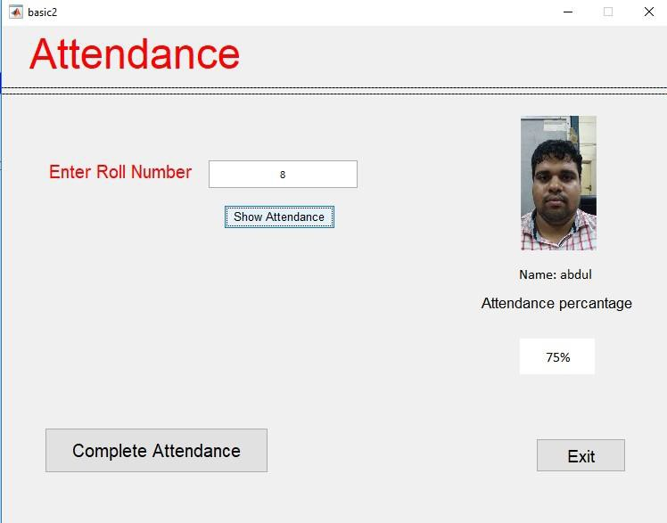

Figure 6.1 Attendance report
Discussion
The attendance report of an individual student can be viewed by entering his or her roll number in the roll number field . The data is displayed at specified box.

Database table

The data base table displays the attendance table,the schema for the student attendance report is given below:

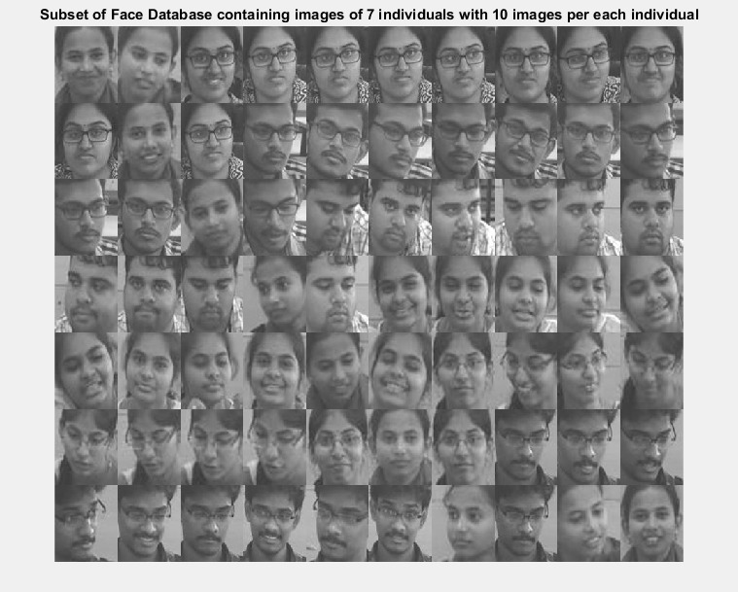

Fig 6.2 : FaceDatabase

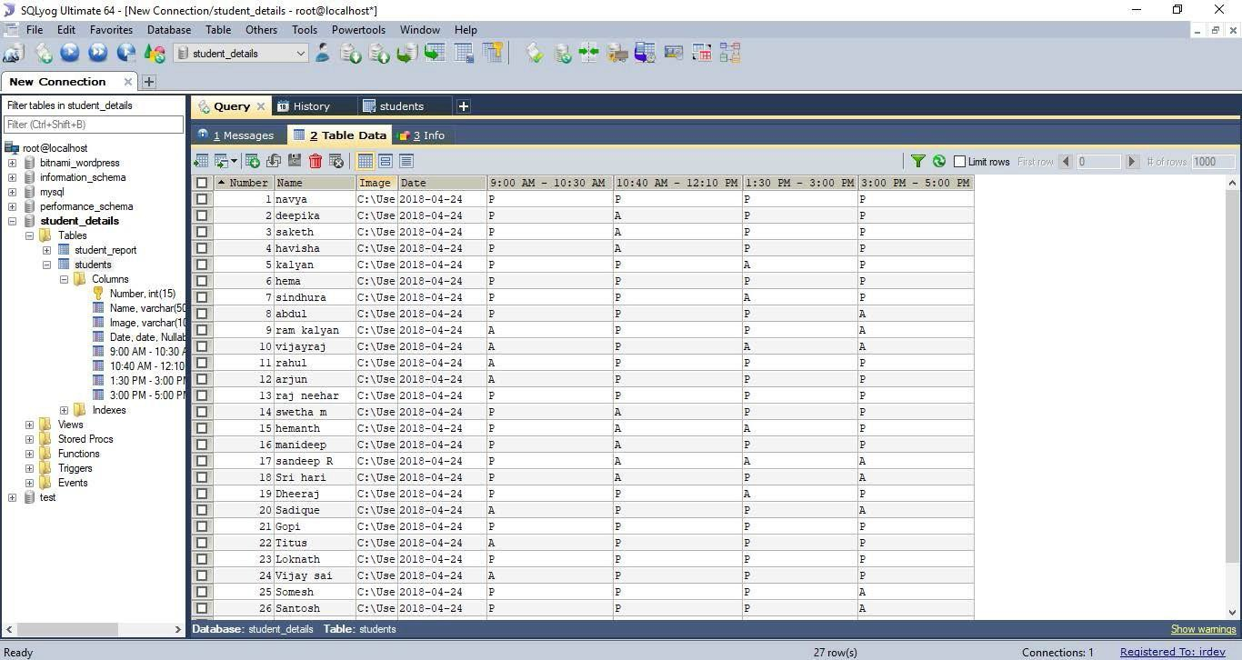

Figure 6.3Datastored in database

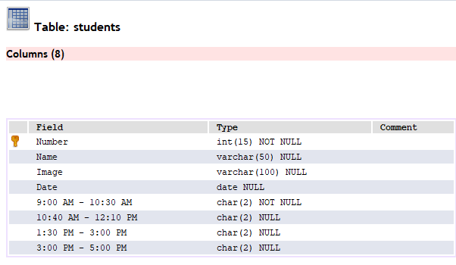

Discussion:

The attendance report stored in Database can be imported into excel sheet. Data will be stored in the form of tables in database.

Face Recognition

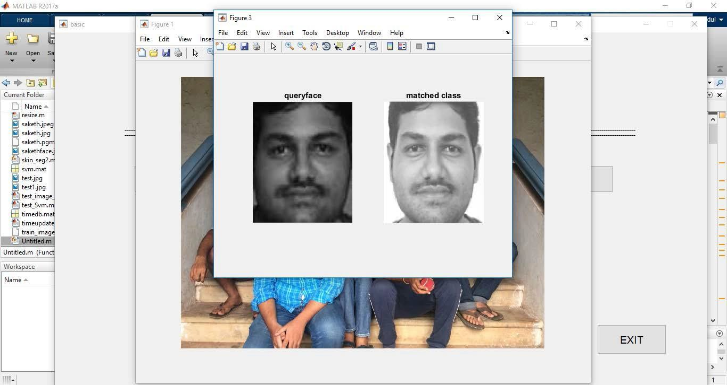

Figure 6.4 Face recognition

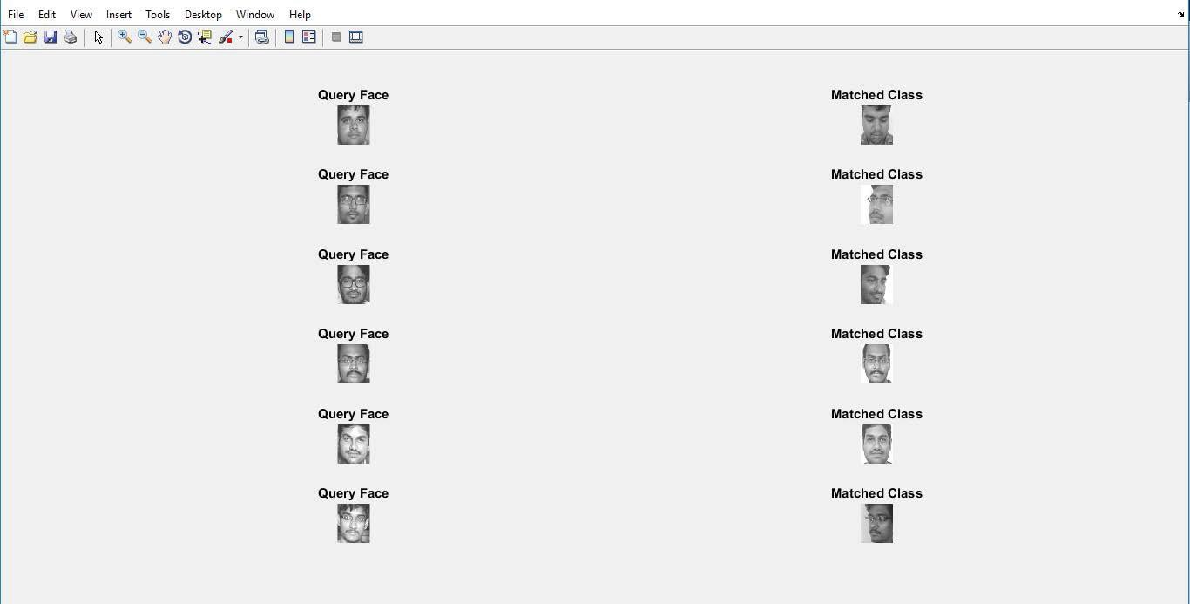

Discussion:
Figure 6.5 Face recognition of all the faces in a group photo

The snapshot from surveillance video is give to the facial recognition algorithm. The faces are detected and recognized .

Automated Attendance System

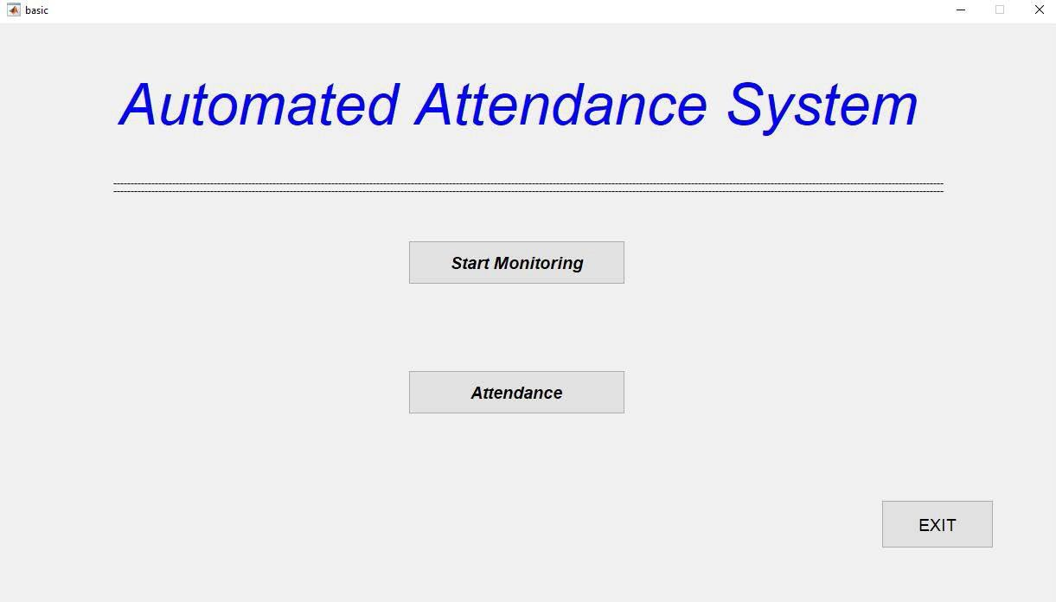

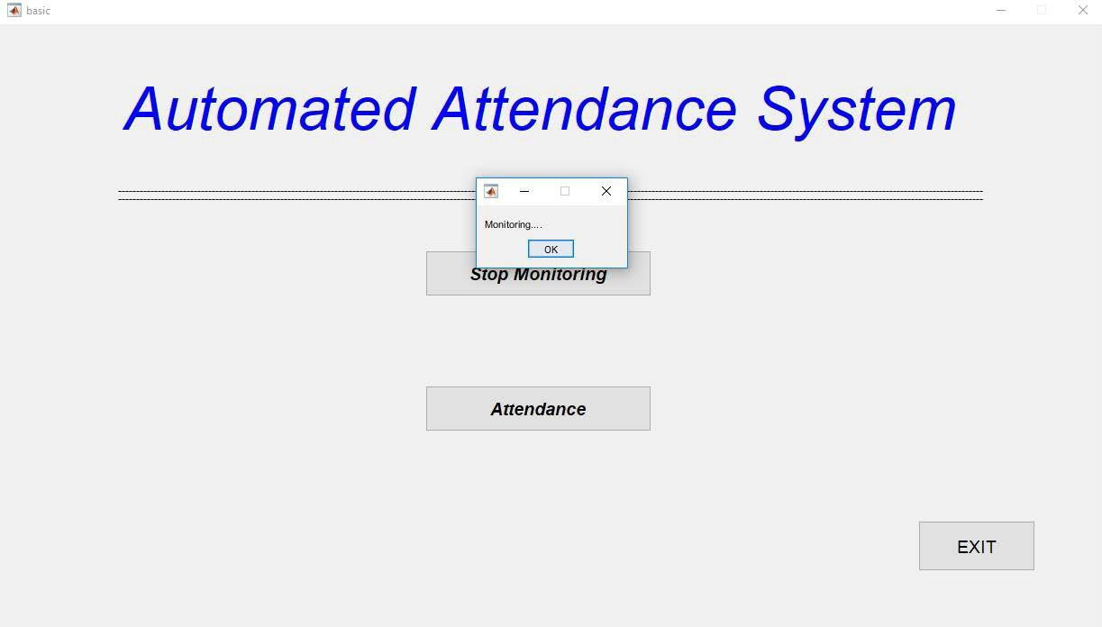
Figure 6.6 Automated Attendance System
Figure 6.7 Monitoring System

CHAPTER – 7

CONCLUSIONS AND FUTURE ENHANCEMENTS

Conclusion

In this project, we have mainly focused on automating the attendance system by face detection and recognition. Facial recognition requires training the machine with training dataset containing facial images of all the students. Digital image of students is taken periodically using camera and an algorithm is applied on it to detect the face of the students and recognize them based on the training data set that was given to the machine. The training process involves extracting essential facial features from the training set. We have used Histogram of oriented Gradient method as the feature extraction method. Next, a classification model is built on the extracted feature set using support vector machine combined with error correcting output codes (ECOC). During runtime, this trained classification model can be used to recognize the students present in the class and mark their attendance. This process continues until all the detected faces of students get their attendance marked in database. Now this database is used to calculate their individual attendance percentage. We can also view the compete record of attendance of students.

Future Enhancements
This system can be further enhanced by using Thermal cameras instead of normal cameras because the class rooms may not be well illuminated. In future a 3D face recognition system can be designed which can give more accurate results.

REFERENCES

[1] Lei, Zhen, et al, “ Real-time face detection and recognition for video surveillance applications ”, Computer Science and Information Engineering, 2009 WRI World Congress on. Vol. 5. IEEE, 2009.
[2] Viola, Paul, and Michael J. Jones, “ Robust real-time face detection ”, International journal of computer vision 57.2 (2004):137-154.
[3] Degtyarev, Nikolay, and Oleg Seredin, ”Comparative testing of face detection algorithms”, Image and Signal Processing. Springer Berlin Heidelberg 2010. 200-209.
[4] T. Lim, S. Sim, and M. Mansor,” RFID based attendance system ”, in Industrial Electronics and Applications, 2009. ISIEA 2009. IEEE Symposium on, vol. 2. IEEE, 2009, pp. 778782.
[5] S. Kadry and K. Smaili,” A design and implementation of a wireless iris recognition attendance management system ”, Information Technology and control, vol. 36, no. 3, pp. 323329, 2007
[6] Faruqe, M.O. and Hasan, M. A. M.(2009). “ Face recognition using PCA and SVM. ” Proceedings of the 3rd International Conference on AntiCounterfeiting, Security and Identification in Communication, Aug. 20- 22, Hong Kong, pp: 97-101.
[7] Turk, M., Pentland, A.: “ Eigenfaces for recognition ” . Journal of Cognitive Neuroscience 3 (1991) 71–86
[8] Ojala, T., Pietik¨ainen, M., M¨aenp¨a¨a, T.: “ Multiresolution gray-scale and rotation invariant texture classification with local binary patterns. ” IEEE Transactions on Pattern Analysis and Machine Intelligence 24 (2002) 971–987

BIBILOGRAPGY

    - https://www.mathworks.com/discovery/face- recognition.html
    - http://epacis.net/jcis/PDF_JCIS/JCIS11-art.0101.pdf
    - https://en.wikipedia.org/wiki/Viola%E2%80%93Jones_ob ject_detection_framework
    - https://www.ijser.org/researchpaper/Implementation-of- Automated-Attendance-System-using-Face- Recognition.pdf
    - https://software.intel.com/en-us/ipp-dev-reference- histogram-of-oriented-gradients-hog-descriptor
    - https://www.rankred.com/face-recognition-algorithms- techniques/
    - http://www.neuroinformatik.ruhr-uni- bochum.de/PEOPLE/wiskott/

